**Group Agreed Documentation**

* Key Functionality

1. Registering a User (Rick)
2. Booking a Session (Genaro)
3. View Schedule (Munir)
4. Add Sessions (Ovi)
5. Check-In Customer (Michael)

* Use Case Diagram (With highlighted chosen functionalities)

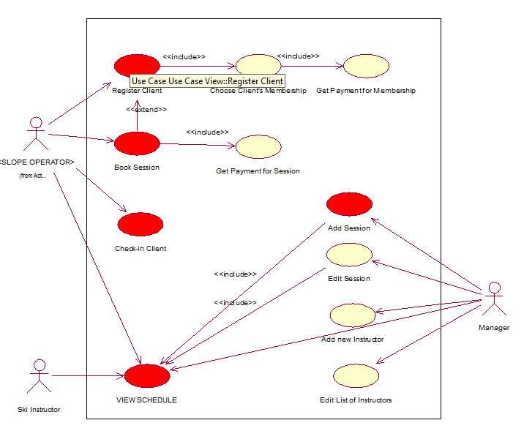

* Deciding on developing a stand-alone system developed in Java using the NetBeans environment
* It will use a SQL database throughout everyone’s functionality